Ideation Phase
Define the Problem Statements

Date | 20th February 2026
Team ID | : LTVIP2026TMIDS38023
Project Name | LearnHub
Maximum Marks | 2 Marks

👩‍🎓 Student-Centered Problem Statements
- “As a student, I need a way to track my progress through a course because I often forget where I left off and lose motivation without visible milestones.”
- “As a learner, I need a way to preview course content before enrolling so I can ensure it matches my learning goals and is worth my time or money.”
- “As a beginner, I need a platform that guides me through what to learn next because I feel overwhelmed by the number of available courses.”
- “As a paying user, I need to receive proof of course completion because I want to showcase my skills on LinkedIn or in job applications.”

👨‍🏫 Teacher-Centered Problem Statements
- “As a course creator, I need a simple way to structure my content into sections and quizzes because it helps students engage and understand better.”
- “As an educator, I need insights into how students are progressing in my course so I can improve the material or offer help where needed.”
- “As an instructor, I need the ability to update or remove courses easily because information in tech and education evolves quickly.”

👩‍💼 Admin-Centered Problem Statements
- “As an admin, I need to monitor student and teacher activity across the platform because I am responsible for ensuring quality and compliance.”
- “As a platform manager, I need to identify the most engaging courses and instructors so I can promote them to improve user satisfaction.”
- “As a support admin, I need a way to manage user reports or content flags because maintaining platform integrity is critical.”
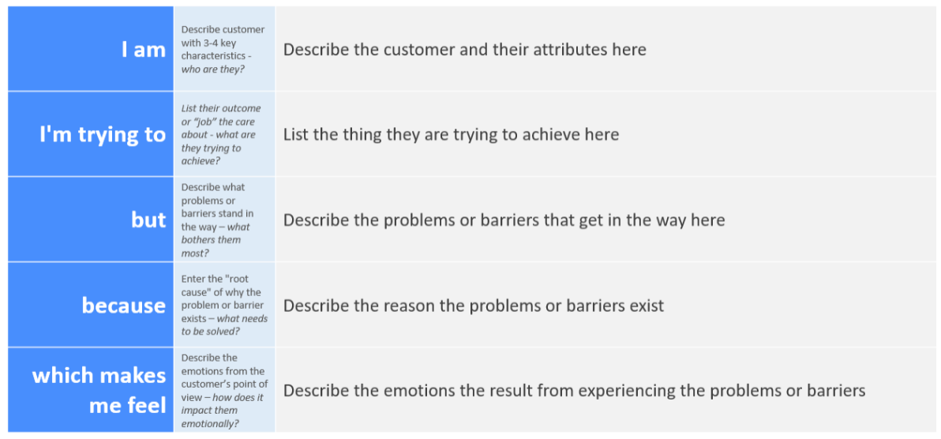
Reference: https://miro.com/templates/customer-problem-statement/
Example:
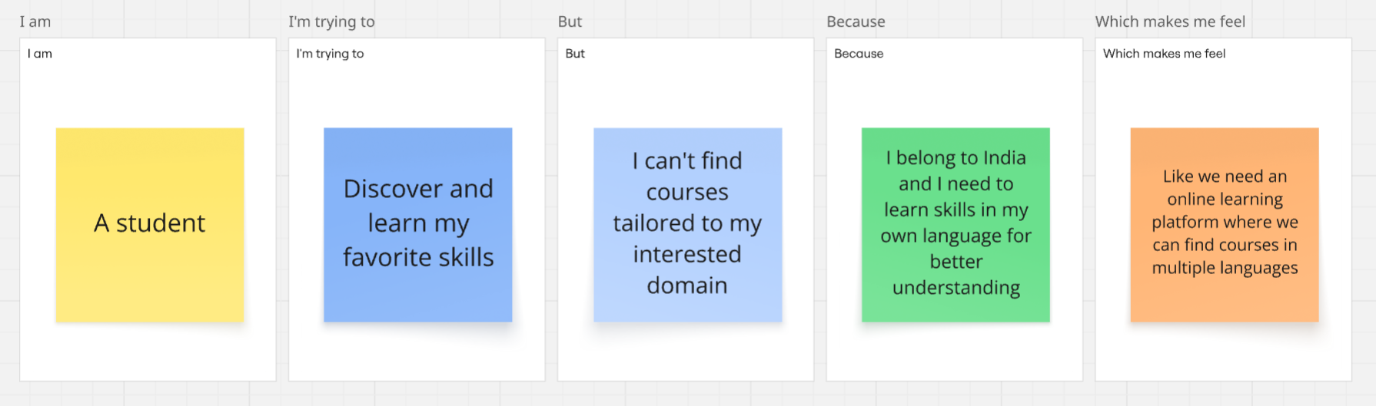

Problem Statement (PS) | I am (Customer) | I’m trying to | But | Because | Which makes me feel
PS-1 | A college student | To learn latest technologies | I can’t find relevant courses near me | I stay in a remote village in India | Like we must have an online learning platform that helps me learn skills I want in language I wish
PS-2 | A trainer | Offer training session at very affordable prices to learners | Most online learning platforms are charging much | They contain courses created by educators who charge very high | Like we need an online learning platform where individual educators who teach at affordable prices can create courses

